**Nucleo STM32F411RET6 = ENTERING ON DFU MOD**

**STEP1**

On board Pin VDD and Pin Boot0 are connected together with jumper the both are close each other

**STEP 2**

USE USB PROTOTYPE (or cut and USB CABLE ON part which you need to connect to NUCLEO)

and connect pins as follow

|  |  |  |
| --- | --- | --- |
| NO | NUCLEO BOARD | USB PROTOTYPE / USB CABLE |
| 1. | 5V | RED CABLE |
| 2 | PA12 + | GREEN CABLE |
| 3 | PA11 - | WHITE CABLE |
| 4 | GND | BLACK CABLE |

**See on picture as described**

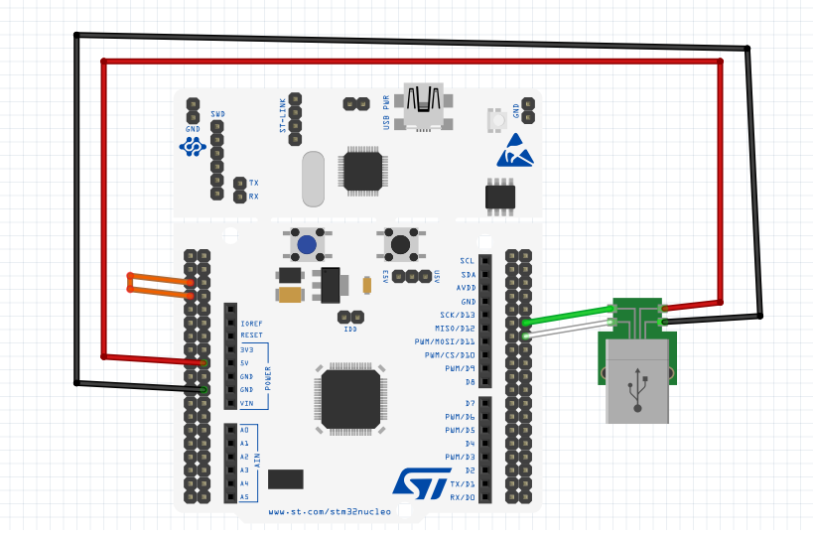

After upload of firmware to to exit from DFU mode (remove ORANGE JUMPER) like following picture (from picture above)

